MidPoint Circle Algorithm

It is based on the following function for testing the spatial relationship between the arbitrary point (x, y) and a circle of radius r centered at the origin:

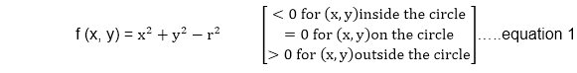  
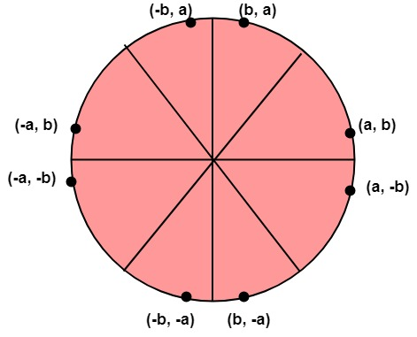

Now, consider the coordinates of the point halfway between pixel T and pixel S

This is called midpoint (xi+1,yi-MidPoint Circle Algorithm) and we use it to define a decision parameter:

            Pi=f (xi+1,yi-MidPoint Circle Algorithm) = (xi+1)2+(yi-MidPoint Circle Algorithm)2-r2 ...............equation 2

If Pi is -ve ⟹midpoint is inside the circle and we choose pixel T

If Pi is+ve ⟹midpoint is outside the circle (or on the circle)and we choose pixel S.

The decision parameter for the next step is:

Pi+1=(xi+1+1)2+(yi+1-MidPoint Circle Algorithm)2- r2............equation 3

Since xi+1=xi+1, we have

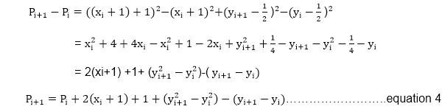

If pixel T is choosen ⟹Pi<0

We have yi+1=yi

If pixel S is choosen ⟹Pi≥0

We have yi+1=yi-1

MidPoint Circle Algorithm

We can continue to simplify this in n terms of (xi,yi) and get

MidPoint Circle Algorithm

Now, initial value of Pi (0,r)from equation 2

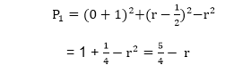

We can put MidPoint Circle Algorithm≅1  
∴r is an integer  
So, P1=1-r

Algorithm:

**Step1:** Put x =0, y =r in equation 2  
            We have p=1-r

**Step2:** Repeat steps while x ≤ y  
            Plot (x, y)  
            If (p<0)  
Then set p = p + 2x + 3  
Else  
            p = p + 2(x-y)+5  
            y =y - 1 (end if)  
            x =x+1 (end loop)

**Step3:** End

Program to draw a circle using Midpoint Algorithm:

1. #include <graphics.h>
2. #include <stdlib.h>
3. #include <math.h>
4. #include <stdio.h>
5. #include <conio.h>
6. #include <iostream.h>
8. **class** bresen
9. {
10. **float** x, y,a, b, r, p;
11. **public**:
12. **void** get ();
13. **void** cal ();
14. };
15. **void** main ()
16. {
17. bresen b;
18. b.get ();
19. b.cal ();
20. getch ();
21. }
22. Void bresen :: get ()
23. {
24. cout<<"ENTER CENTER AND RADIUS";
25. cout<< "ENTER (a, b)";
26. cin>>a>>b;
27. cout<<"ENTER r";
28. cin>>r;
29. }
30. **void** bresen ::cal ()
31. {
32. /* request auto detection */
33. **int** gdriver = DETECT,gmode, errorcode;
34. **int** midx, midy, i;
35. /* initialize graphics and local variables */
36. initgraph (&gdriver, &gmode, " ");
37. /* read result of initialization */
38. errorcode = graphresult ();
39. **if** (errorcode ! = grOK)    /*an error occurred */
40. {
41. printf("Graphics error: %s \n", grapherrormsg (errorcode);
42. printf ("Press any key to halt:");
43. getch ();
44. exit (1); /* terminate with an error code */
45. }
46. x=0;
47. y=r;
48. putpixel (a, b+r, RED);
49. putpixel (a, b-r, RED);
50. putpixel (a-r, b, RED);
51. putpixel (a+r, b, RED);
52. p=5/4)-r;
53. **while** (x<=y)
54. {
55. If (p<0)
56. p+= (4*x)+6;
57. **else**
58. {
59. p+=(2*(x-y))+5;
60. y--;
61. }
62. x++;
63. putpixel (a+x, b+y, RED);
64. putpixel (a-x, b+y, RED);
65. putpixel (a+x, b-y, RED);
66. putpixel (a+x, b-y, RED);
67. putpixel (a+x, b+y, RED);
68. putpixel (a+x, b-y, RED);
69. putpixel (a-x, b+y, RED);
70. putpixel (a-x, b-y, RED);
71. }
72. }

**Output:**

